***Working with Razor Syntax***

*Create an empty MVC application > Right click on Controller folder > Add > Controller > Named HomeController > Add the following code snippet in the HomeController*

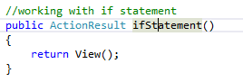

*Add a view for ifStatement action method> add the following code snippet:*

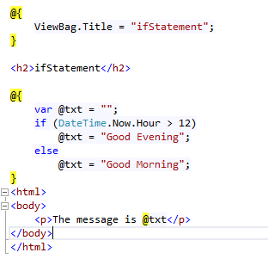

*The output would be:*

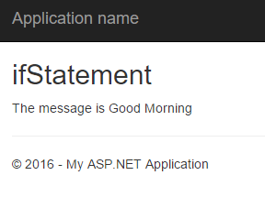

*Add the following code snippet in the HomeController*

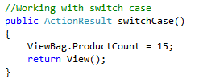

*Add a view for switchCase action method> add the following code snippet:*

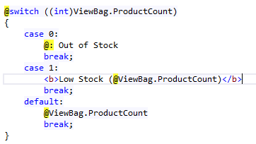

*The output would be:*

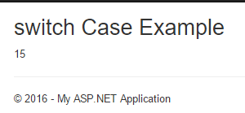

*Add the following code snippet in the HomeController*

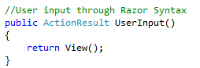

*Add a view for UserInput action method> add the following code snippet:*

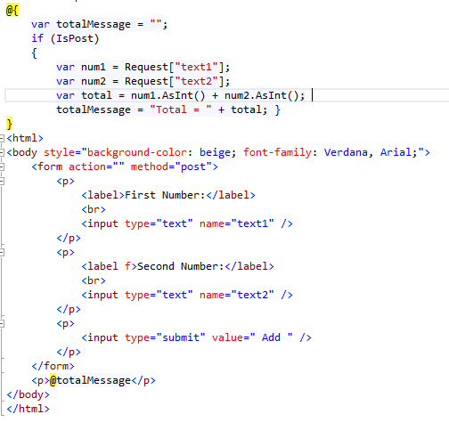

*The output would be:*

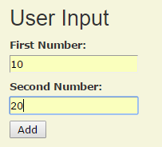 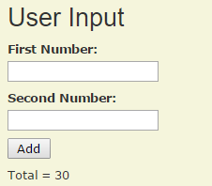

*Add the following code snippet in the HomeController*

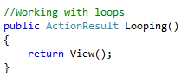

*Add a view for Looping action method> add the following code snippet:*

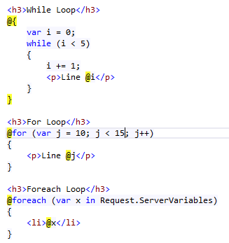

*The output would be*

*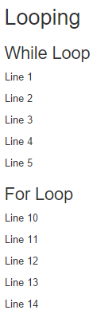: 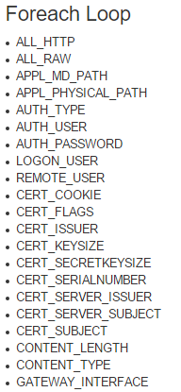*

*Add the following code snippet in the HomeController*

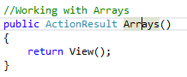

*Add a view for Arrays action method> add the following code snippet:*

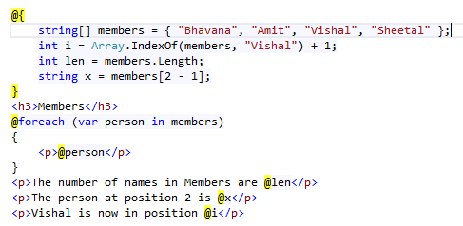

*The output would be:*

